Spring 2023: CS5710 – Machine Learning

In-Class Programming Assignment-2

Name - Nikhil Manikya

ID- 700734200

GitHub Link -<https://github.com/NikhilManikya123/700734200_ML_Assignment_2>

1. Use a python code to display the following star pattern using the for loop

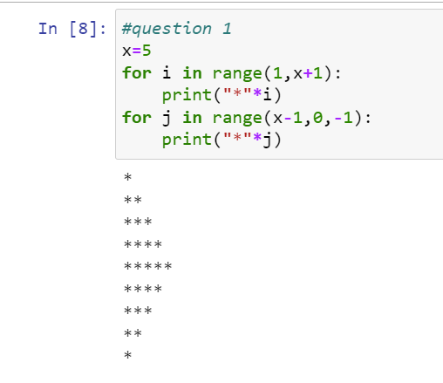

2. Use looping to output the elements from a provided list present at odd indexes.

my_list = [10, 20, 30, 40, 50, 60, 70, 80, 90, 100]

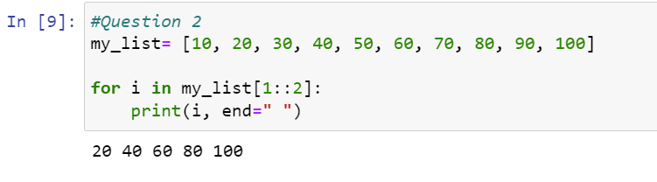

3. Write a code that appends the type of elements from a given list.

Input x = [23, ‘Python’, 23.98]

Expected output [23, 'Python', 23.98]

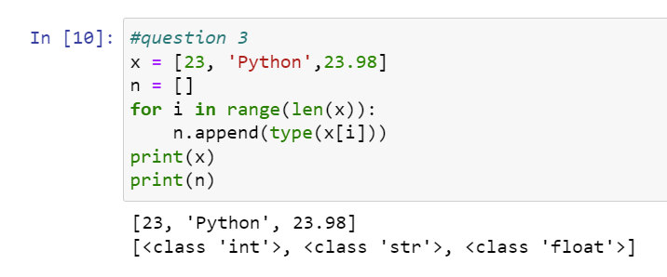

4. Write a function that takes a list and returns a new list with unique items of the first list. Sample List: [1,2,3,3,3,3,4,5]

Unique List: [1, 2, 3, 4, 5]

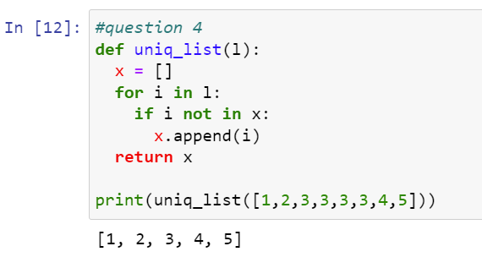

5. Write a function that accepts a string and calculate the number of upper-case letters and lower-case letters.

Input String: 'The quick Brow Fox'

Expected Output: No. of Upper-case characters: 3 No. of Lower-case Characters: 12

